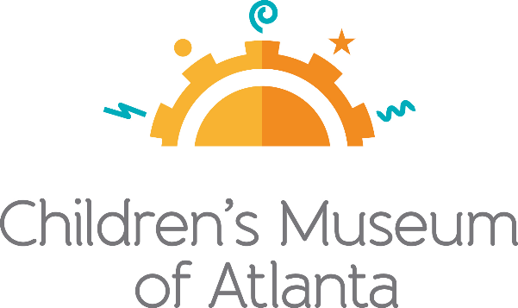

CONTACT
Jennifer Walker
BRAVE Public Relations
404.233.3993
jwalker@emailbrave.com

*MEDIA ADVISORY*
Children’s Museum of Atlanta presents ‘CMA Town Square:
Let's Talk about Parenting During a Pandemic’ in September
Program provides expert advice to help parents navigate at-home learning and other topics

ATLANTA (September 9, 2020) – Children’s Museum of Atlanta has long served as a gathering place where families, educators and others come together to learn about and discuss issues important to the community. Following the program’s launch in July, the Museum is continuing its series with a new topic in September, CMA Town Square: Let's Talk about Parenting During a Pandemic. The virtual interview series that aims to help families and educators navigate the new world of at-home learning and provides resources that help children have an easier and more enjoyable learning experience. Weekly guest speakers will discuss topics such as virtual learning, child development, mental health and more. During this challenging time, Children’s Museum of Atlanta is proud to offer resources that help families and their children stay on track to a successful school year.

Each 30-minute session includes up to 10 minutes of audience Q&A. The sessions will take place on Facebook live stream and will be posted on Children’s Museum of Atlanta YouTube channel with a list of resources.

WHAT: CMA Town Square: Let's Talk about Parenting During a Pandemic
Children’s Museum of Atlanta is proud to offer the Atlanta community a resource that can help families navigate the virtual learning experience and implement a system that best suits the needs of their children

WHEN: Thursdays at 10 a.m. (excluding Sept. 10)
Guest speakers will have a 30-minute conversation with time for Q&A

September 10 at 11:30 a.m. – Digital Inclusion: Caitlin McMunn Dooley, Ph.D. – Deputy Superintendent for Teaching and Learning at the Georgia Department of Education and a Full Professor of Education at Georgia State University

September 17 – Virtual Learning and Concerns About Screen Time: Meghan Welch, Ph. D. – Program Specialist at the Georgia Department of Education; topic geared for elementary school students

September 24 – Navigating Learning Needs Through Developmental Stages: Bridget Ratajczak – Child and Development Supervisor at the Georgia Department of Early Care and Learning: Bright from the Start (DECAL); topic geared for children up to kindergarten age

WHERE: Children’s Museum of Atlanta Facebook
Families are invited to join guest speakers live on Children’s Museum of Atlanta’s Facebook or watch later on Children’s Museum of Atlanta’s YouTube

HOW: This digital series is free and open to the community; for more information
visit: childrensmuseumatlanta.org/cma-town-square

For more information or to support Children's Museum of Atlanta, visit childrensmuseumatlanta.org
or call 404.659.KIDS [5437]

